**REFLECTIVE REPORT ON THE**

**APPLICATION FOR XHAW5112 2025**

**The Group Members**

Tyrese Sheraan Ah-Dong

Khulekani Emmanuel Shongwe

Pembleton Phiri

Nicole Elizabeth Fick

Evelyn Ivy Kamanga

Mohamed A A Elzawawi

**This document contains the following information and build on the following screens:**

* HOMEPAGE
* SIX MONTH COURSES PAGE
* SIX WEEK COURSES PAGE
* FIRST AID PAGE
* SEWING PAGE
* LANDSCAPING PAGE
* LIFE SKILLS PAGE
* CHILD MINDING PAGE
* COOKING PAGE
* GARDEN MAINTENANCE PAGE
* SELECT COURSES PAGE
* CALCULATE FEES PAGE
* THANK YOU PAGE
* CONTACT US PAGE

**Homepage:**

* The Homepage consists of the title of the business (Empowering The Nation) with its logo right beside it fitted in its own container apart from the container of the actual screen.
* Below this is the ABOUT US text provided with a box that contains the information about the business.
* Below this the user can find the courses on offer and below that the option to choose between the six-month courses or the six-week courses, when the user touches the text of either course, the touchable opacity function coded in the text will navigate them to the desired information screen of the course.
* Below this the user can also find a button that navigates the user to the CONTACT US page of the business.
* The design and colours of this screen are catered for simplicity and colours that are compatible with visually impaired people. (e.g. colour-blind).

**Six-month Courses page:**

* This page has its own container different from the Homepage container due to it having its own unique colour.
* This in screen the user will find the different courses offered for the six-month courses provided with the function to navigate to their respective screens via touchable opacity with a navigation function.
* Below this is an image that has been coded that contains the information regarding the different discounts offered per course selected.
* This screen remains consistent with the title and logo found in the Homepage.
* Courses found on this page are First-Aid, Sewing, Landscaping and Life-Skills.

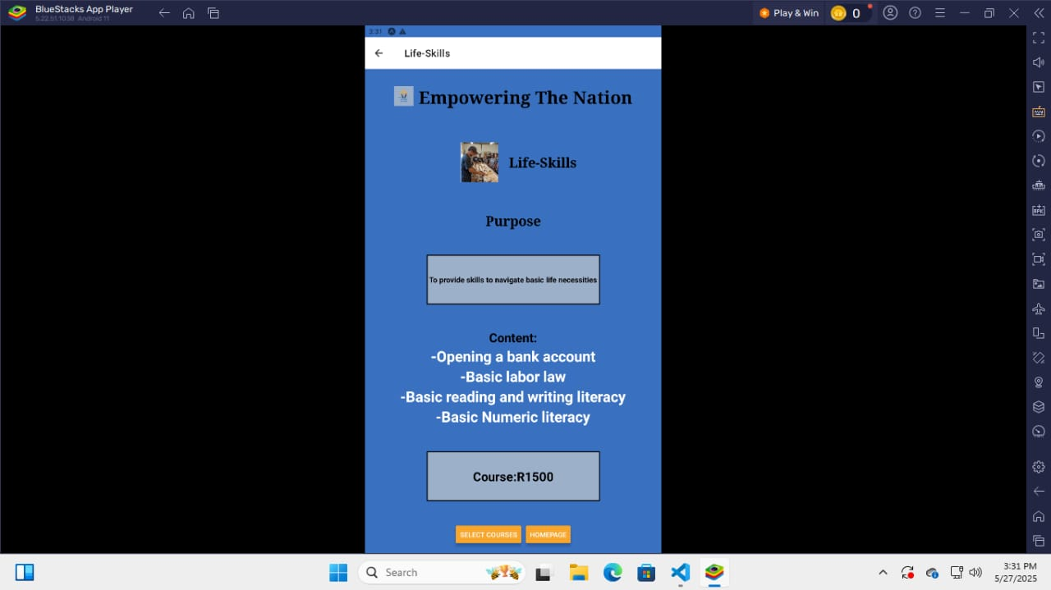

**First-Aid Page:**

* This screen containers its own container as well.
* In this page the user can see all the information about the first-aid course provided. These include a box that contains the course’s purpose and below that the content that will be covered in the six-month duration of the course.
* Another box is coded to provide the user with the course price as well.
* Below this is a 2 button in their own container whereby the user can either choose to go the SELECT COURSES page or VIEW NEXT to navigate to the next course within the six-month package.

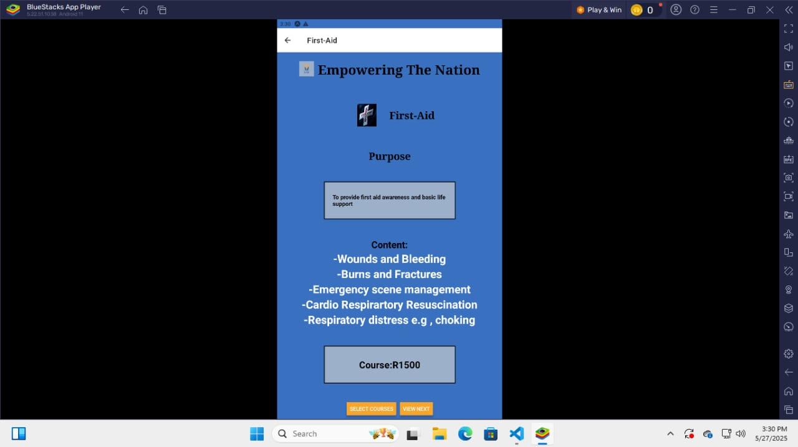

**Sewing Page:**

* This screen containers its own container as well.
* In this page the user can see all the information about the first-aid course provided. These include a box that contains the course’s purpose and below that the content that will be covered in the six-month duration of the course.
* Another box is coded to provide the user with the course price as well.
* Below this is a 2 button in their own container whereby the user can either choose to go the SELECT COURSES page or VIEW NEXT to navigate to the next course within the six-month package.

**Landscaping Page:**

* This screen containers its own container as well being consistent with the business’ logo. (This goes for all screens).
* In this page the user can see all the information about the first-aid course provided. These include a box that contains the course’s purpose and below that the content that will be covered in the six-month duration of the course.
* Another box is coded to provide the user with the course price as well.
* Below this is a 2 button in their own container whereby the user can either choose to go the SELECT COURSES page or VIEW NEXT to navigate to the next course within the six-month package.

**Life-Skills Page:**

* This screen containers its own container as well.
* In this page the user can see all the information about the life-skills course provided. These include a box that contains the course’s purpose and below that the content that will be covered in the six-month duration of the course.
* Another box is coded to provide the user with the course price as well.
* Below this is a 2 button in their own container whereby the user can either choose to go the SELECT COURSES page or VIEW NEXT to navigate to the next course within the six-month package.

**Six-week Courses page:**

* This page has its own container different from the Homepage container due to it having its own unique colour.
* This in screen the user will find the different courses offered for the six-month courses provided with the function to navigate to their respective screens via touchable opacity with a navigation function.
* Below this is an image that has been coded that contains the information regarding the different discounts offered per course selected.
* This screen remains consistent with the title and logo found in the Homepage.
* Courses found on this page are Cooking, Child Minding and Garden Maintenance.

**Child Minding Page:**

* This screen containers its own container as well.
* In this page the user can see all the information about the child-minding course provided. These include a box that contains the course’s purpose and below that the content that will be covered in the six-week duration of the course.
* Another box is coded to provide the user with the course price as well.
* Below this is a 2 button in their own container whereby the user can either choose to go the SELECT COURSES page or VIEW NEXT to navigate to the next course within the six-month package.

**Cooking Page:**

* This screen containers its own container as well.
* In this page the user can see all the information about the cooking course provided. These include a box that contains the course’s purpose and below that the content that will be covered in the six-month duration of the course.
* Another box is coded to provide the user with the course price as well.
* Below this is a 2 button in their own container whereby the user can either choose to go the SELECT COURSES page or VIEW NEXT to navigate function to the next course within the six-month package.

**Garden Maintenance Page:**

* This screen containers its own container as well.
* In this page the user can see all the information about the garden maintenance course provided. These include a box that contains the course’s purpose and below that the content that will be covered in the six-month duration of the course.
* Another box is coded to provide the user with the course price as well.
* Below this is a 2 button in their own container whereby the user can either choose to go the SELECT COURSES page or VIEW NEXT to navigate to the next course within the six-month package.

**About us page**

On the About page, we have the description of the app, the business, the purpose of it and the founder of the company.

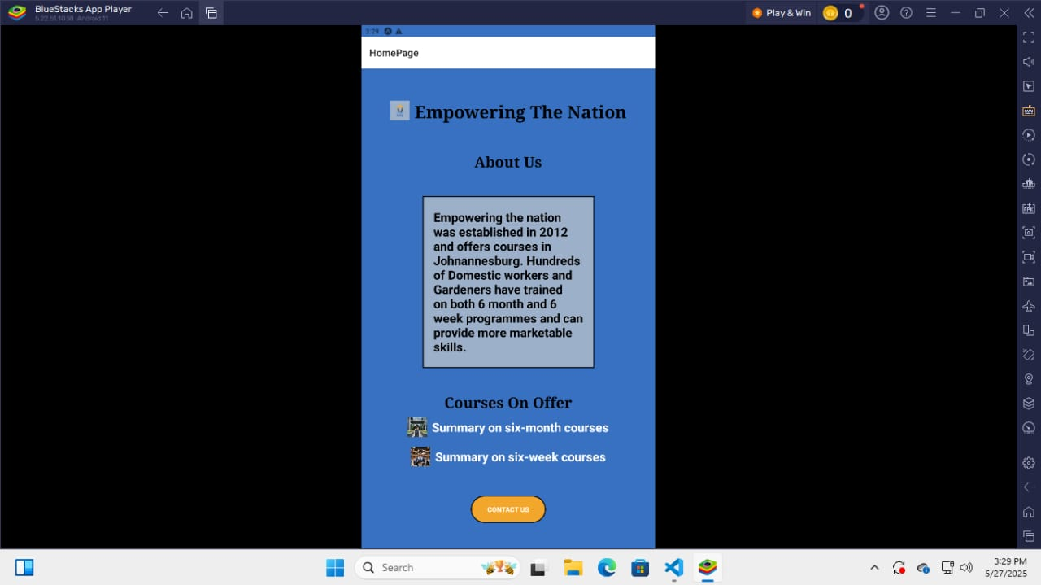

**Calculating Fees**

The total fees page is a page where it prompts the user to choose the course(s) they want, and it shows the outcome. If the user chooses one course, it doesn’t give a discount it only works when the user chooses two or more courses. Once we press the calculate total button it will show us the total fee, subtotal, the discount you get, the amount after discount and the VAT of 15%. The screenshots below to show the functionality of the total fees page.

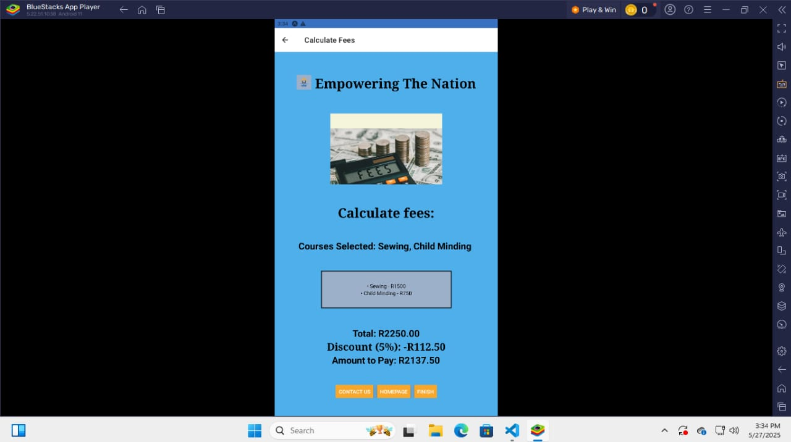

**Functionality of the Website**

The website consists of home page, six months courses, six weeks courses, about page, total costs page and a contact page. On the home page there is a brief explanation of what the business is all about.

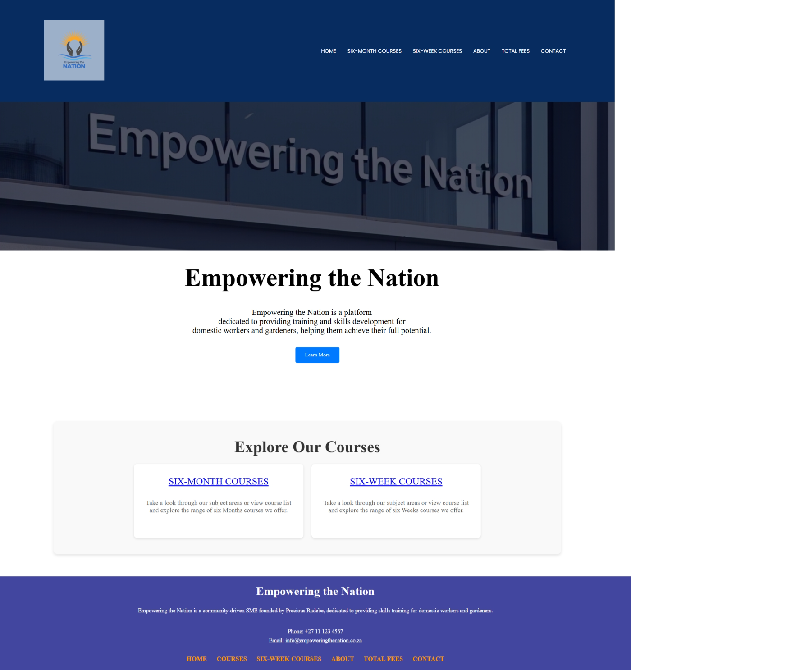

On the six months courses we have first aid, sewing, landscaping and life skills. Each page for example the first aid has the description of the course and the content and the fees. The screenshot below illustrates that.

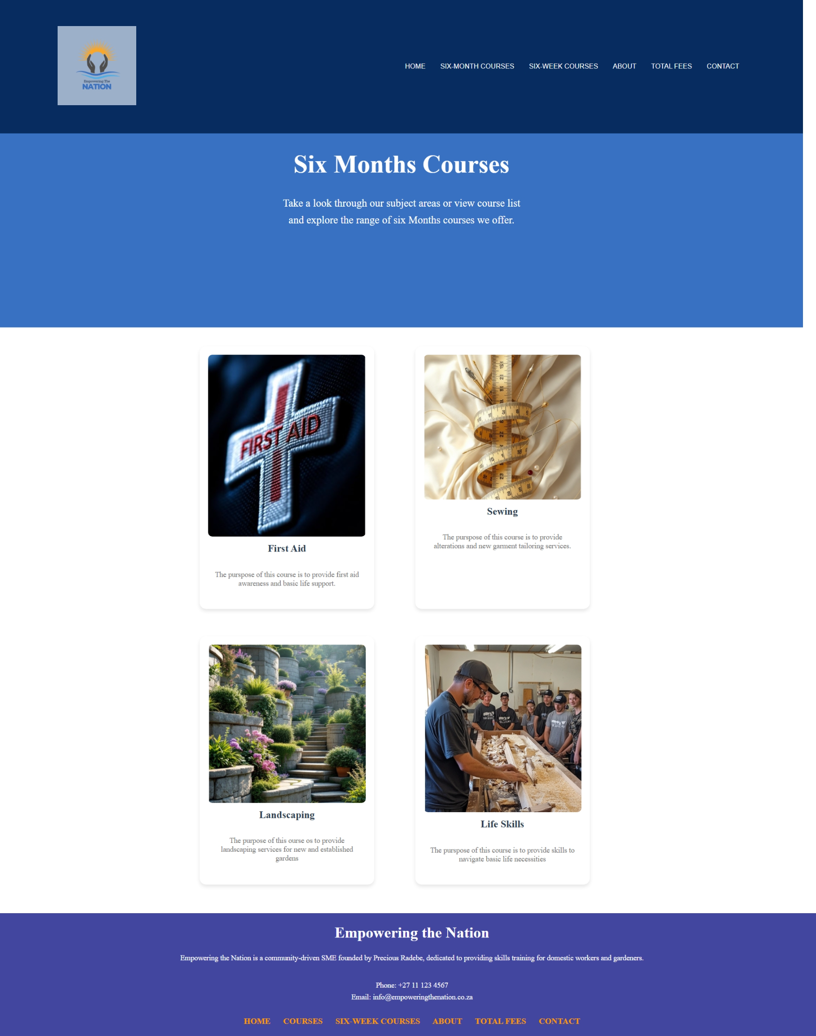

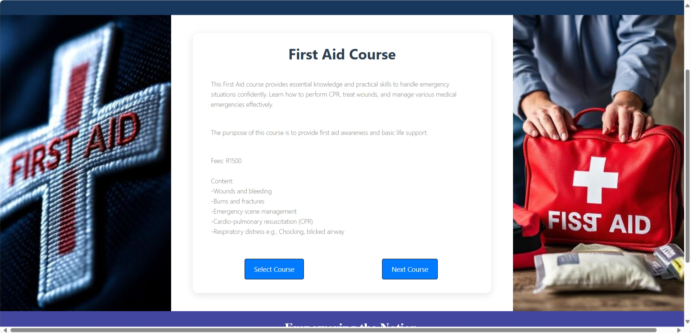

On six weeks courses we have child minding, cooking and garden maintenance. Each course also shows the content of the course, fees and its purpose. Below is a screenshot of it.

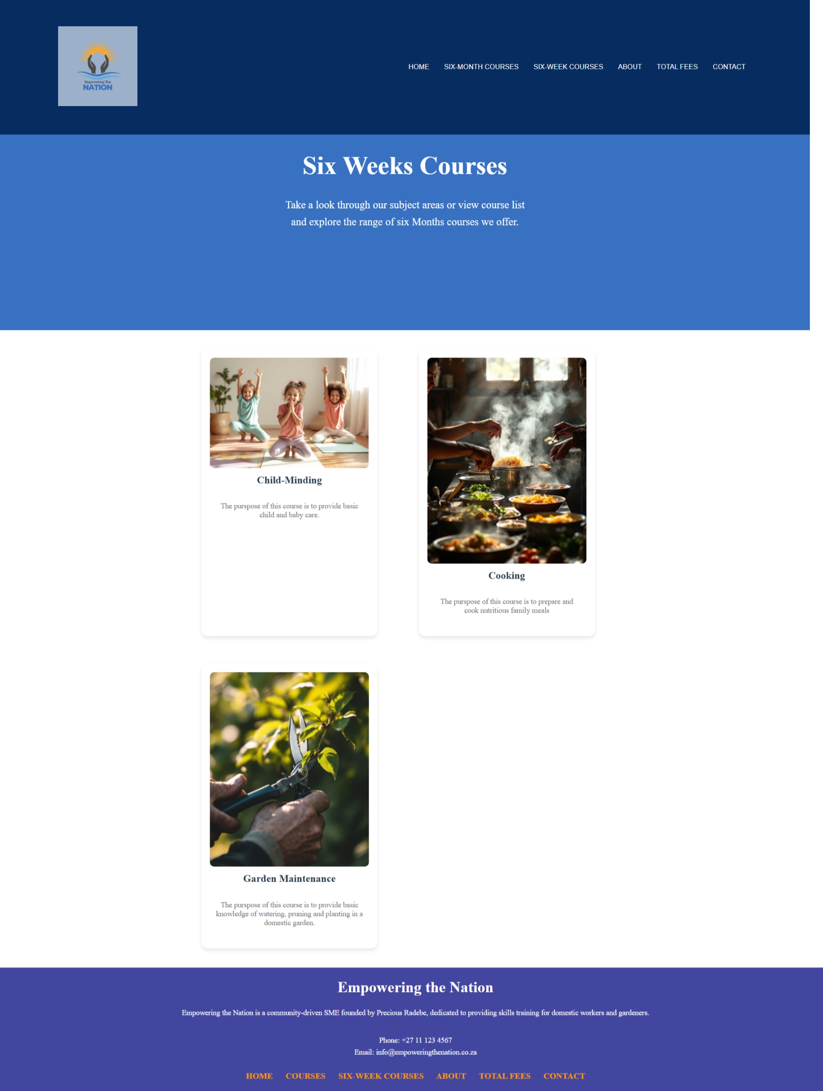

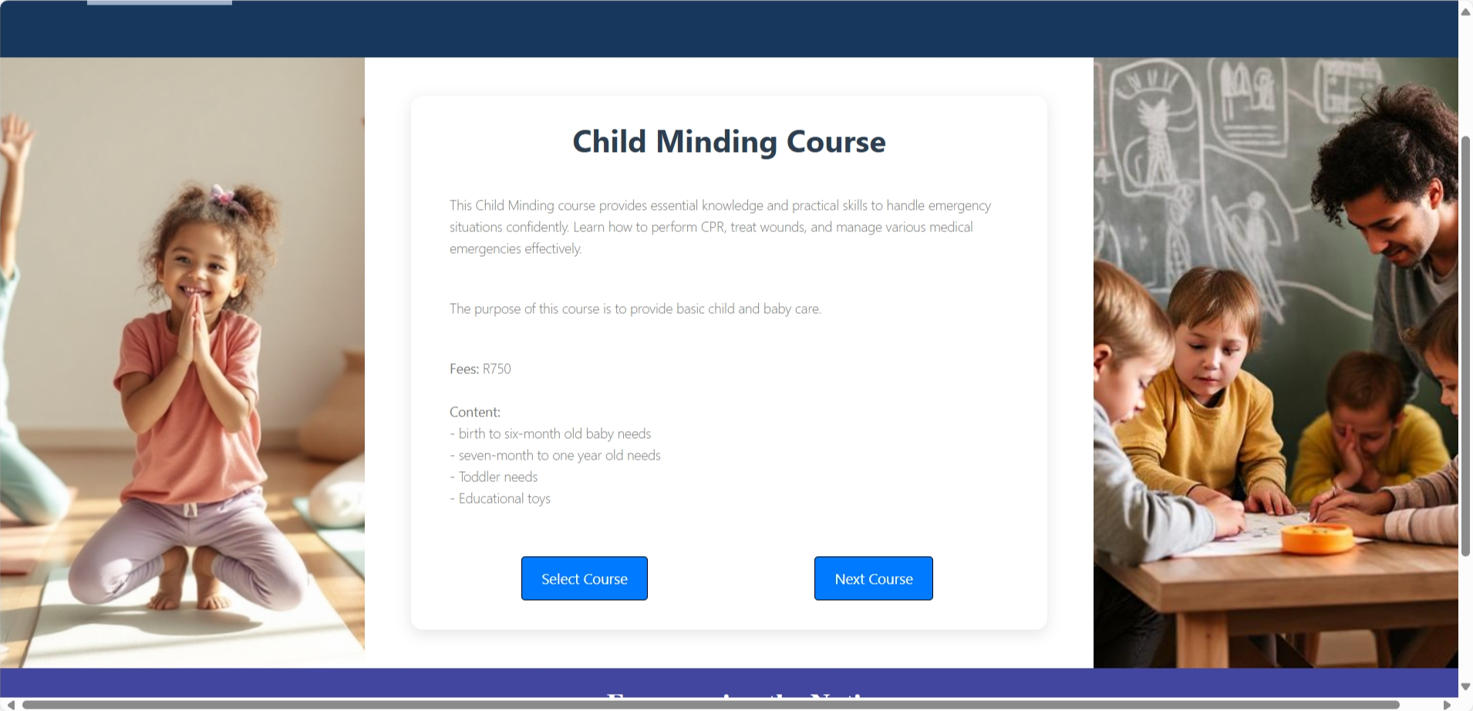

On the About page, we have the description of the company, the purpose of it and the founder of the company.

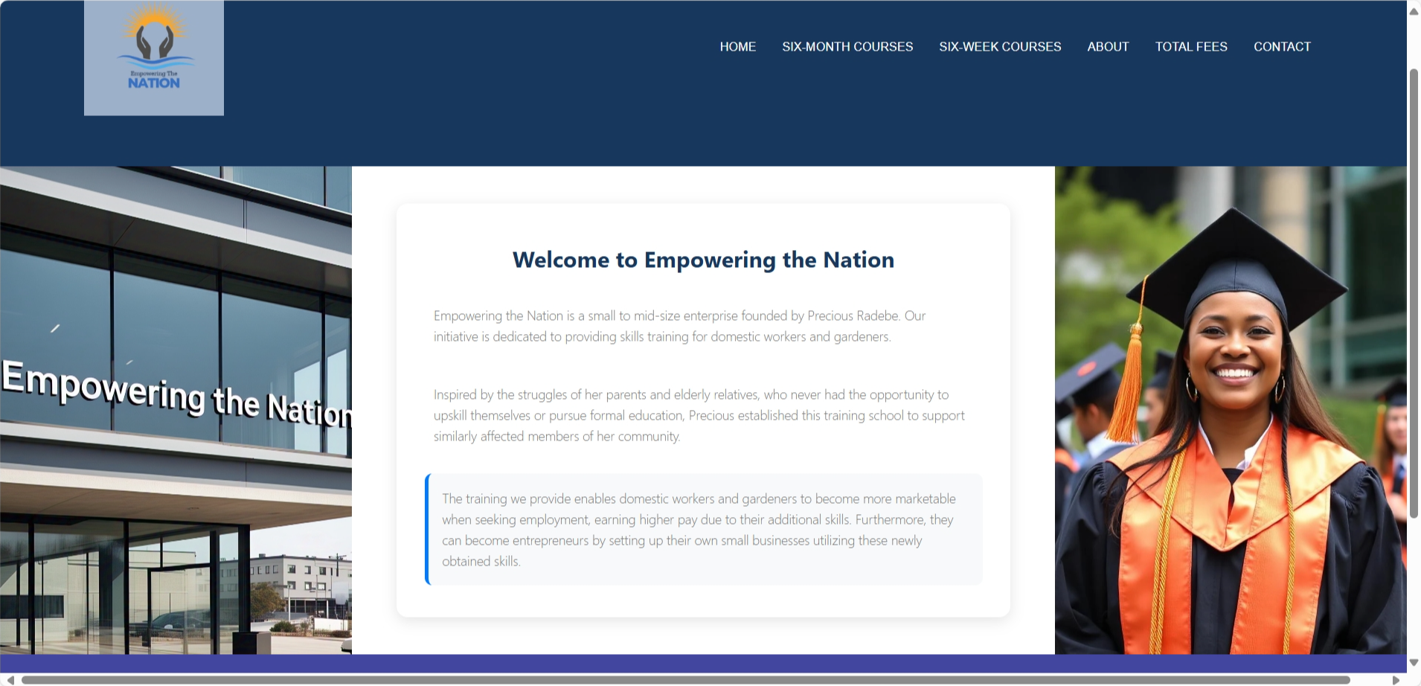

The total fees page is a page where it prompts the user to choose the course(s) they want, and it shows the outcome. This page requires the use to enter their name, phone number and email address so that it can send the outcome there. If the user chooses one course, it doesn’t give a discount it only works when the user chooses two or more courses. Once we press the calculate total button it will show us the total fee, subtotal, the discount you get, the amount after discount and the VAT of 15%. The screenshots below to show the functionality of the total fees page.

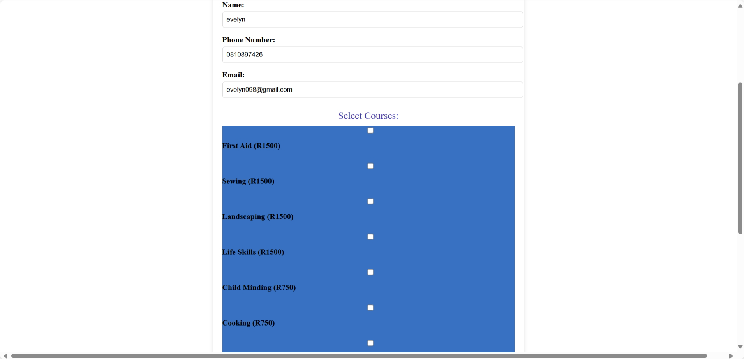

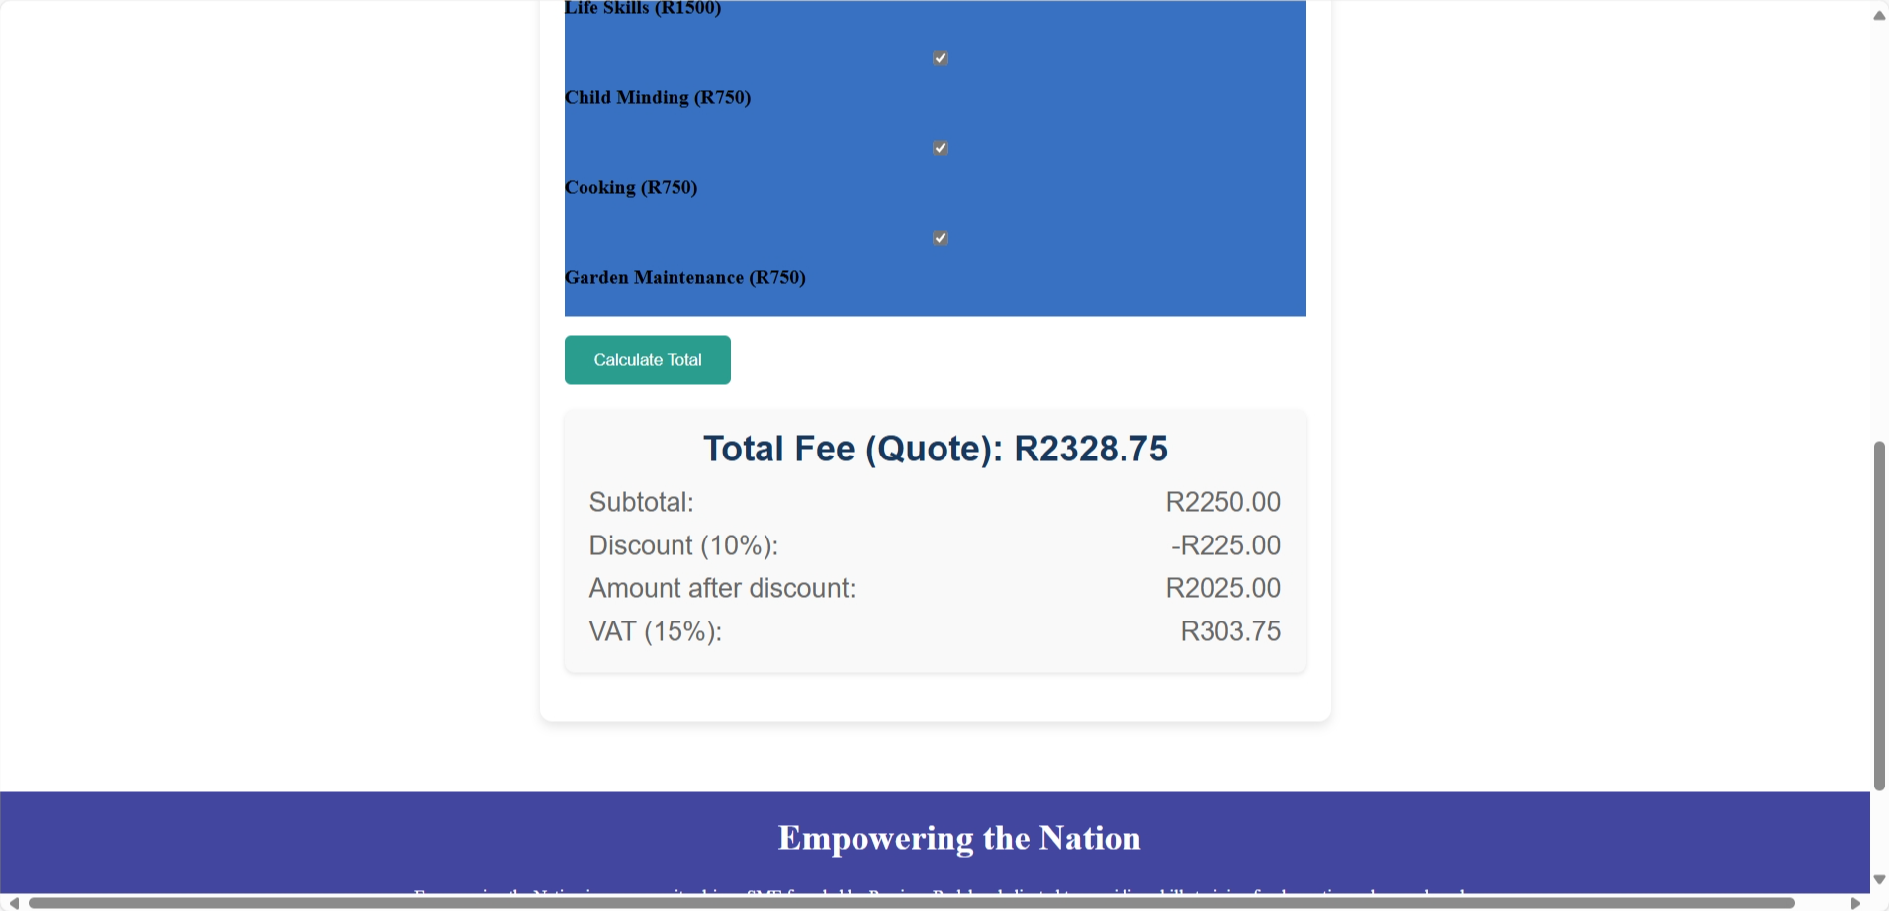

The last page on the website is the contact page. On this page we have the phone number of the company and the email address. It also shows the venues of the company in Centurion, Soweto and Midrand. The maps are live location as soon as you click on them, they take you to a map where you can get directions. Below are the screenshots of the functionality.

